**Q. Create a program for bill payment using AngularJS.**

**CODE:**

<!DOCTYPE html>

<html lang="en">

<head>

<meta charset="UTF-8">

<script src = "https://ajax.googleapis.com/ajax/libs/angularjs/1.6.9/angular.min.js"></script>

<title>Bill</title>

</head>

<body>

<div ng-app="invoice">

<section>

</section>

<section ng-controller="InvoiceController">

<table>

<thead>

<tr>

<th>Name</th>

<th>Description</th>

<th>Qty</th>

<th>Price</th>

<th>Total</th>

<th>Delete</th>

</tr>

</thead>

<tbody>

<tr ng-repeat="item in invoice.items">

<td><input type="text" ng-model="item.name"/></td>

<td><input type="text" ng-model="item.description" /></td>

<td><input type="number" ng-model="item.qty" /></td>

<td><input type="number" ng-model="item.price"/></td>

<td>{{item.qty * item.price}} Rs.</td>

<td><button type="button" ng-click="remove($index)">Delete</button>

</td>

</tr>

<tr>

<td><button type="button" ng-click="add()">Add item</button></td>

<td></td>

<td></td>

<td>Total : </td>

<td>{{total()}} Rs.</td>

</tr>

</tbody>

</table>

</section>

</div>

</body>

<script>

var invoice = angular.module('invoice', []);

invoice.controller('InvoiceController', function ($scope) {

$scope.invoice = {

items: [{

name: 'Item 1',

description: 'Item 1 description',

qty: 5,

price: 50

}]

};

$scope.add = function () {

$scope.invoice.items.push({

name: '',

description: '',

qty: 1,

price: 0

});

},

$scope.remove = function (index) {

$scope.invoice.items.splice(index, 1);

},

$scope.total = function () {

var total = 0;

angular.forEach($scope.invoice.items, function (item) {

total += item.qty * item.price;

})

return total;

}

});

</script>

</html>

**OUTPUT:**

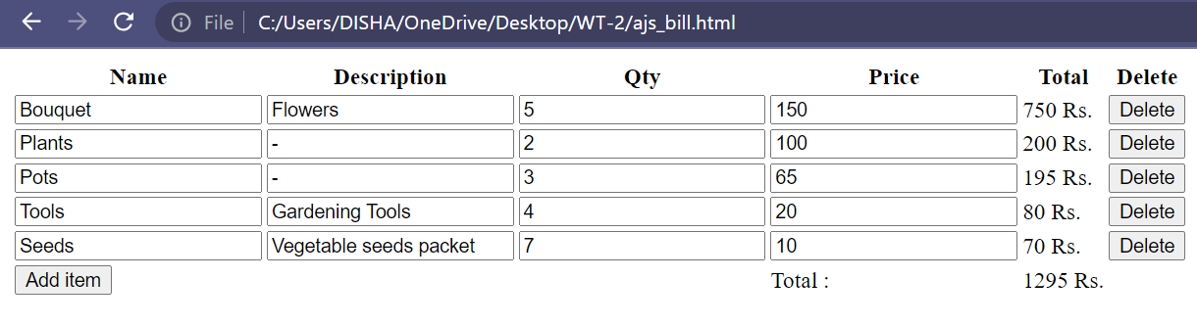

**Q. Write a program for a simple calculator using AngularJS.**

**CODE:**

<!DOCTYPE html>

<html>

<script src="https://ajax.googleapis.com/ajax/libs/angularjs/1.6.9/angular.min.js"></script>

<title>Calculator Using Angular JS</title>

<body>

<script>

angular.module('CalculatorApp', []).controller('CalculatorController', function ($scope) {

$scope.result = function () {

if ($scope.operator == '+') {

return $scope.a + $scope.b;

}

if ($scope.operator == '-') {

return $scope.a - $scope.b;

}

if ($scope.operator == '*') {

return $scope.a * $scope.b;

}

if ($scope.operator == '/') {

return $scope.a / $scope.b;

}

};

});

</script>

<div ng-app="CalculatorApp" ng-controller="CalculatorController">

<p><input type="number" ng-model="a"></p>

<p><input type="number" ng-model="b"></p>

<p><select ng-model="operator">

<option>+</option>

<option>-</option>

<option>*</option>

<option>/</option>

</select></p>

<p>{{ result() }}</p>

</div>

</body>

</html>

**OUTPUT:**

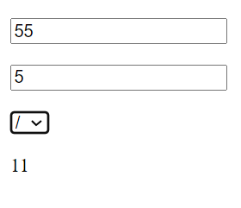

**Q. Write a program using AngularJS for form validation.**

**CODE:**

<!DOCTYPE html>

<html ng-app="formValidationApp">

<head>

<meta charset="UTF-8">

<title>Form Validation</title>

<script src="https://ajax.googleapis.com/ajax/libs/angularjs/1.7.9/angular.min.js"></script>

<script>

angular.module('formValidationApp', [])

.controller('FormValidationController', function ($scope) {

$scope.submitForm = function () {

if ($scope.registrationForm.$valid) {

alert('Form submitted successfully!');

}

};

});

</script>

</head>

<body ng-controller="FormValidationController">

<div>

<h2>Registration</h2>

<form name="registrationForm" ng-submit="submitForm()" novalidate>

<label for="firstname">First Name:</label>

<input type="text" name="firstname" ng-model="user.firstname" ng-required="true"><br>

<label for="lastname">Last Name:</label>

<input type="text" name="lastname" ng-model="user.lastname"><br>

<label for="email">Email:</label>

<input type="email" name="email" ng-model="user.email" ng-required="true"><br>

<label for="password">Password:</label>

<input type="password" name="password" ng-model="user.password" ng-minlength="8" ng-required="true"><br>

<input name="submit" type="submit" value="Submit" ng-disabled="registrationForm.$invalid">

</form>

</div>

</body>

</html>

**OUTPUT:**

